CTM-I Use Case

Firm Security Maintenance

Version 0.1

Use Case Name | Firm Security Maintenance
Actor | Firm System Admin
Pre-conditions /Assumptions | At least one Firm Level Security Role has been defined in the system.  User has rights to access the Firm Security Maintenance page.  User has selected the Firm Security Maintenance option from the Menu.
Post Conditions | The user has the option of returning to the Firm Security Maintenance Use Case.
Screenshot | 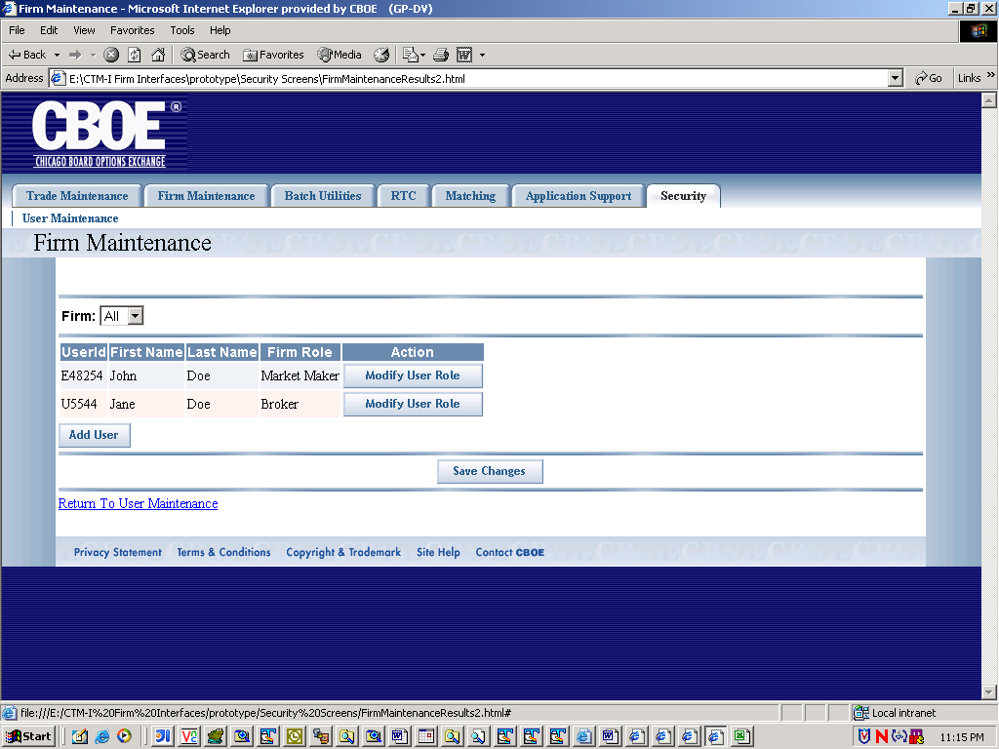
Flow of Events | Modify Role  Alternate  ADD NEW USER
   | User | System
  1 | User logs into CTMI application
   |  | System verifies that user has rights to maintain Firm Security.
   |  | Application retrieves user’s available firms.
  2 | User selects the Firm Security Maintenance option
   |  | System displays the Firm Maintenance screen
  3 | User selects a firm.
  System returns a list of users that have been assigned a firm role for the firm. The following data is displayed:
  Userid:
  First Name:
  Last Name:
  Firm Role
  4 | User selects the modify user Role option
  5. |  | System returns with a pop-up with the following information:  Userid:  First Name:  Last Name:  Firm Role: The firm Role is editable.
  6. | User changes the Role for the particular user, and closes the popup.
  7. |  | The results are added to the non-editable version of the user information.
  8 | User selects the option to save changes available on the main jsp.
  9 |  | The system persists the user firm role changes, and returns a list of users for the selected firm with the new user firm role changes.
  8.b | User selects option to add user. | .
   |  | System returns with a user search pop-up with the following search criteria:
   | User enters in some or all of the search criteria
   |  | System searches for the users and returns with a list of users.
   | User selects a user
   |  | System retrieves the users details and puts the details in the main Firm Security Maintenance screen
   | User clicks on the modify user role and goes through steps 5-9.
   | User selects the save option | System goes validates roles, and user changes and persists the data.

